Paper Segment #3

Name: Karma Chou
Assignment Number: 3
Class Name: Analysis Modeling & Design - 01 (Fall 2026)
Professor: Dr. Jonathan Reichental
Date: 2026/09/24

- Activity Diagram
- Create campaign & Goal
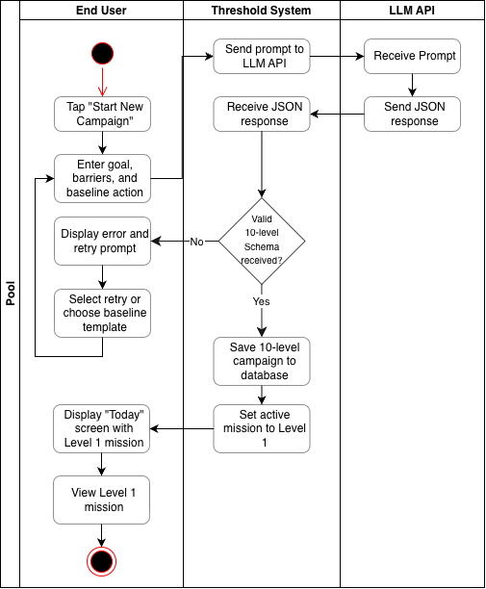
- Complete post-mission debrief + Adjust difficulty
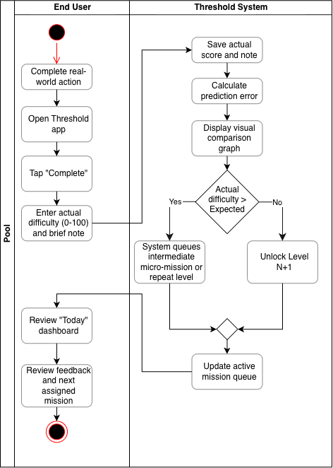
2. List of Things in the Problem Domain
A. Core User & Goal Tracking
userProfile
- Description: Represents the end user taking action to cross psychological thresholds and build real-world competence.
- Attributes: userID {PK}, fullName, emailAddress, currentThresholdScore, accountCreatedDate, userStatus
campaign
- Description: Represents an overarching high-stakes ambition created by the user (e.g., networking with startup founders).
- Attributes: campaignID {PK}, ambitionText, frictionPoint, baselineAction, totalLevels, createdTimestamp, campaignStatus
mission
- Description: An individual real-world action generated as part of a campaign progression (Levels 1–10).
- Attributes: missionID {PK}, levelNumber, missionTitle, missionDescription, targetContext, isCompleted

B. Behavioral Exposure & Learning Data (Incidents / Events)
preMissionRating
- Description: Captures the user's anticipated difficulty or anxiety score before attempting a mission.
- Attributes: ratingID {PK}, expectedDifficulty, submissionTimestamp
missionDebrief
- Description: Captures real-world outcomes, actual difficulty, and reflection immediately following a mission attempt.
- Attributes: debriefID {PK}, actualDifficulty, predictionError, reflectionNotes, completedTimestamp
capabilityMap
- Description: Stores the user's psychological terrain map across specific friction domains over time (e.g., strangers, authority figures).
- Attributes: mapID {PK}, categoryName, capabilityScore, lastUpdatedDate

C. System Administration & Auditing
promptRule
- Description: Stores backend prompt structures and JSON guardrails used by the LLM service to decompose goals into campaigns.
- Attributes: ruleID {PK}, promptTemplate, jsonSchemaVersion, lastUpdatedDate
feedbackReport
- Description: Stores user-submitted bug reports, defect tickets, or application feedback.
- Attributes: reportID {PK}, reportCategory, commentText, dateSubmitted, reportStatus
apiUsageLog
- Description: Tracks LLM token consumption, latency, and API execution costs for administrative monitoring.
- Attributes: logID {PK}, tokensUsed, callTimestamp, callStatus, estimatedCost

3.Domain Model Class Diagram
